Faculty of International Relations Model United Nations
Application Form
Human Rights Council

Part I
General Information
Full name
Birth Date
University

Faculty and speciality
Academic year
E-mail
Telephone number
Participation in Models UN (list the names of MUNs in which you’ve participated)

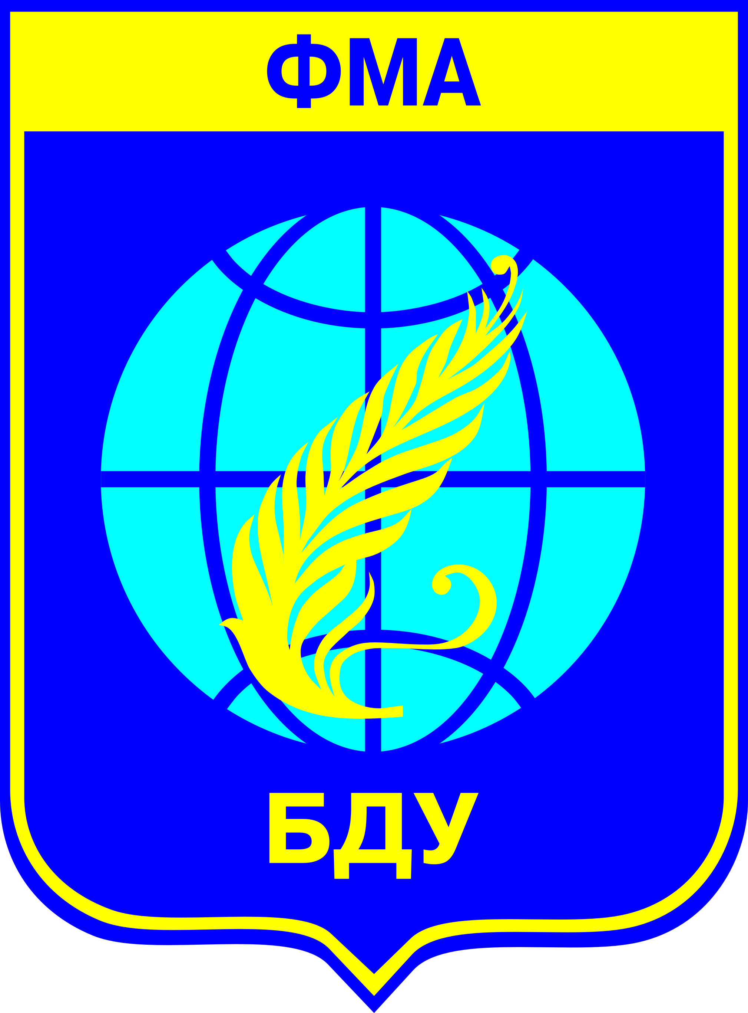
Model UN will be held with the support of
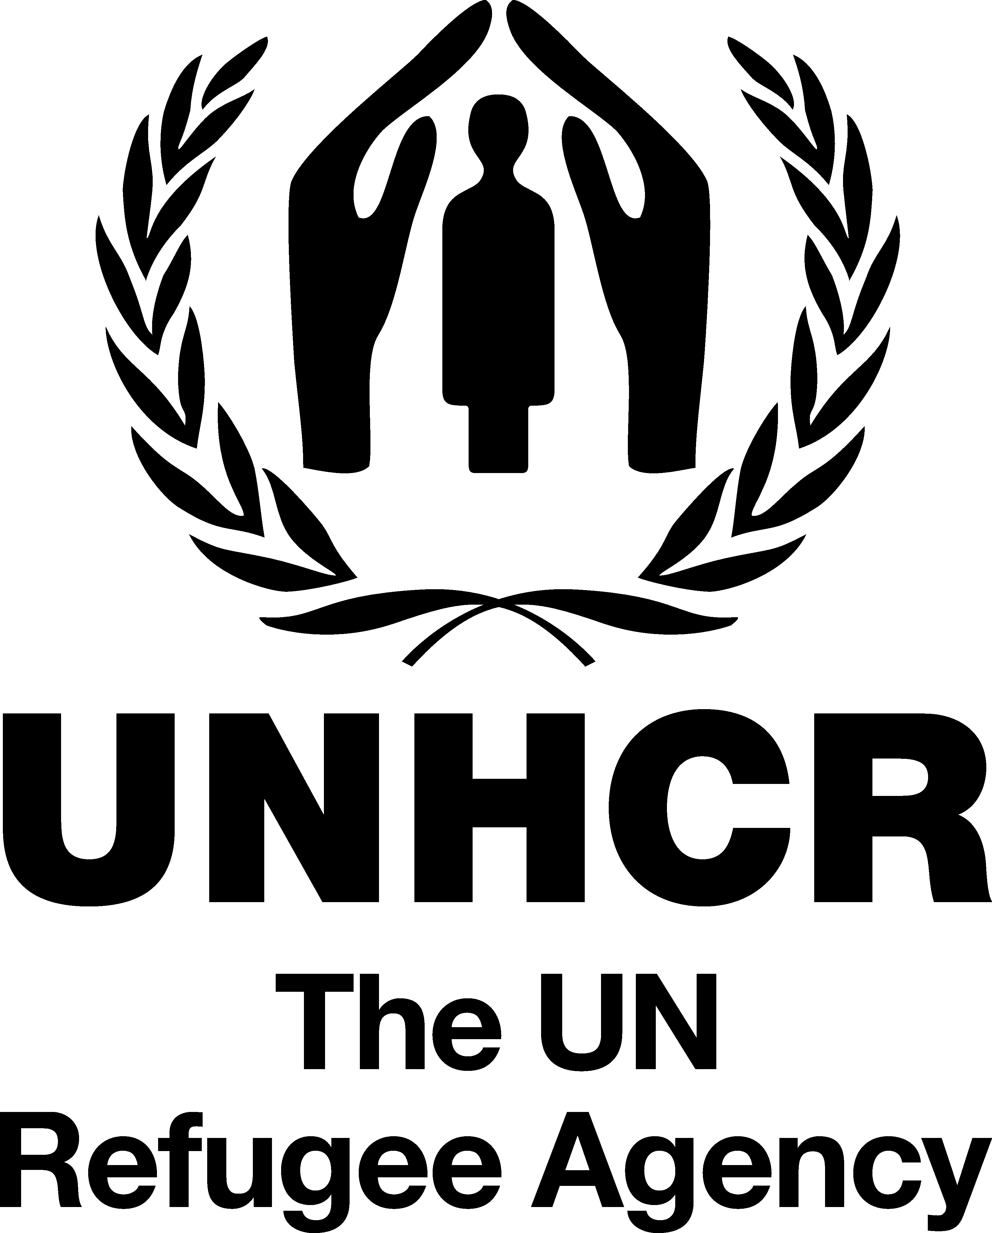
the Faculty of International Relations of Belarusian State University
United Nations High Commissioner for Refugees
International Non-governmental Association for Scientific Research,
Information and Educational Programmes “Evolutio”

Part II
Below on this page you will find the list of the countries arranged in English alphabetical order which are now the members of the Human Rights Council. At the next page we have left blank spaces where you are to place 5 countries downright according to your preferences.
AFRICAN STATES | LATIN AMERICAN & CARIBBEAN STATES
Algeria (2016)  Benin (2014)  Botswana (2014)  Burkina Faso (2014)  Congo (2014)  Côte d’Ivoire (2015)  Ethiopia (2015)  Gabon (2015)  Kenya (2015)  Morocco (2016)  Namibia (2016)  Sierra Leone (2015)  South Africa (2016) | Argentina (2015)  Brazil (2015)  Chile (2014)  Costa Rica (2014)  Cuba (2016)  Mexico (2016)  Peru (2014)  Venezuela (Bolivarian Republic of) (2015)
ASIA-PACIFIC STATES | WESTERN EUROPE & OTHER STATES
China (2016)  India (2014)  Indonesia (2014)  Japan (2015)  Kazakhstan (2015)  Kuwait (2014)  Maldives (2016)  Pakistan (2015)  Philippines (2014)  Republic of Korea (2015)  Saudi Arabia (2016)  United Arab Emirates (2015)  Viet Nam (2016) | Austria (2014)  France (2016)  Germany (2015)  Ireland (2015)  Italy (2014)  United Kingdom of Great Britain and Northern  Ireland (2016)  United States of America (2015)
EASTERN EUROPEAN STATES

Czech Republic (2014)
Estonia (2015)
Montenegro (2015)
Romania (2014)
Russian Federation (2016)
The former Yugoslav Republic of Macedonia (2016)

Make a list below:

Remember! That you are expected to follow only your country’s policy and refrain from expressing your personal attitude on the issue under discussion.
You will be informed about the country you’ll represent no later than in a week before the FIRMUN Session Opening.

