Faculty of International Relations Model United Nations
Application Form
Security Council
Part I
General Information
Full name
Birth Date
Faculty and speciality
Academic year
E-mail
Telephone number
Participation in Models UN (list the names of MUNs in which you’ve participated)

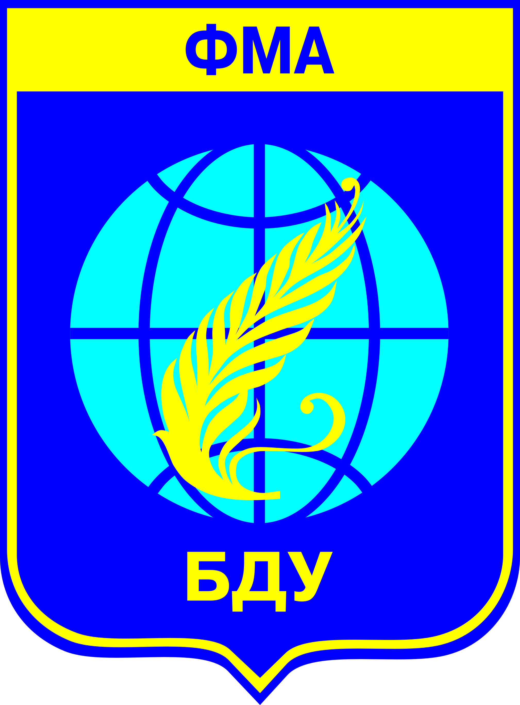
Model UN will be held with the support of

the Faculty of International Relations of Belarusian State University
United Nations High Commissioner for Refugees
International Non-governmental Association for Scientific Research,
Information and Educational Programmes “Evolutio”

Part II
Below, in the left column, you will find the list of the countries arranged in English alphabetical order which are now the members of the Security Council. In the right column we have left blank spaces where you are to place the countries downright according to your preferences.

Make a list below:

Argentina
Australia
Chad
Chile
China
France
Jordan
Lithuania
Luxembourg
Nigeria
Republic of Korea
Russian Federation
Rwanda
The United Kingdom
The United States

Remember! That you are expected to follow only your country’s policy and refrain from expressing your personal attitude on the issue under discussion.
You will be informed about the country you’ll represent no later than in a week before the FIRMUN Session Opening.

